Climate extremes erode the temporal complexity of seasonal communities
Climate variation and extreme events shape the seasonal organization of communities
Volker H. W. Rudolf^{1*}, Daniel Saenz²
Affiliations
¹Corresponding author, Program of Ecology & Evolutionary Biology, BioSciences, Rice University; Houston, TX 77005, USA
²USDA Forest Service Southern Research Station; Nacogdoches, TX 75965, USA
*Corresponding author: Volker.rudolf@rice.edu

Abstract (100-125 words)
As the climate is changing, the frequency of extreme weather events is expected to increase, but their role in shaping the temporal organization of communities that defines species interactions and ecosystem processes remains elusive. By applying a temporal network framework to decadal multi-site data on amphibian breeding communities, we reveal a volatile seasonal architecture, characterized by a “small-world” transition network shaped by general scaling rules and the interplay between local environmental filters and interannual climate variability. However, drought conditions simplify this temporal organization, as extreme climatic forcing overrides seasonal coordination among species and reduces modularity, community state and transition diversity, leading to a simpler, more centralized architecture. This shift suggests that climate change can erode the temporal complexity and diversity of natural ecosystems, thereby reducing their resilience to future perturbations.
Introduction
Ecological communities are not static entities, but instead transient assemblages that fluctuate as species emerge, become active, migrate, reproduce, or go dormant at different times of the year (1-5). While the spatial redistribution of biodiversity under climate change has been extensively studied, we still lack a comparable understanding of the temporal organization of annual communities and how it responds to climate change (6, 7). Because community members typically respond idiosyncratically to environmental cues (8-12), climate change has the potential to reshape the temporal architecture of seasonal communities. Since this architecture defines species interactions, energy flow, disease transmission, and ecosystem resilience (6, 13-17), filling this conceptual gap is critical to understanding the fundamental mechanisms that shape natural ecosystems and their resilience in the face of a quickly changing climate.
Research on intra-annual (seasonal) community patterns has largely relied on “snapshot” approaches that compare communities at discrete time points (1, 4, 18-22). While this pioneering work revealed the dynamic nature of communities and broad seasonal patterns, these methods inherently overlook critical components of the underlying temporal organization: the specific sequence of community states, the timing of transitions, and the duration between them (6, 7). Capturing how climate shapes this temporal blueprint of communities is historically challenging because it requires high-resolution, long-term datasets across multiple communities and analytical tools capable of capturing rapid intra-annual shifts in community composition. Here, we tackle this challenge by applying a novel transition network framework to a 24-year dataset of 841,632 observations of daily breeding activity of 12 amphibian species across 8 sites. By treating community states as nodes and transitions as edges, we characterize the temporal architecture of 192 unique annual communities to identify general rules governing their temporal architecture and their conservation across time and space (Fig. 1). This framework allows us to move beyond static snapshots toward a mechanistic understanding of how climate variability and extreme events reshape community dynamics at ecologically relevant timescales, in one of the most threatened taxonomic groups globally (23).
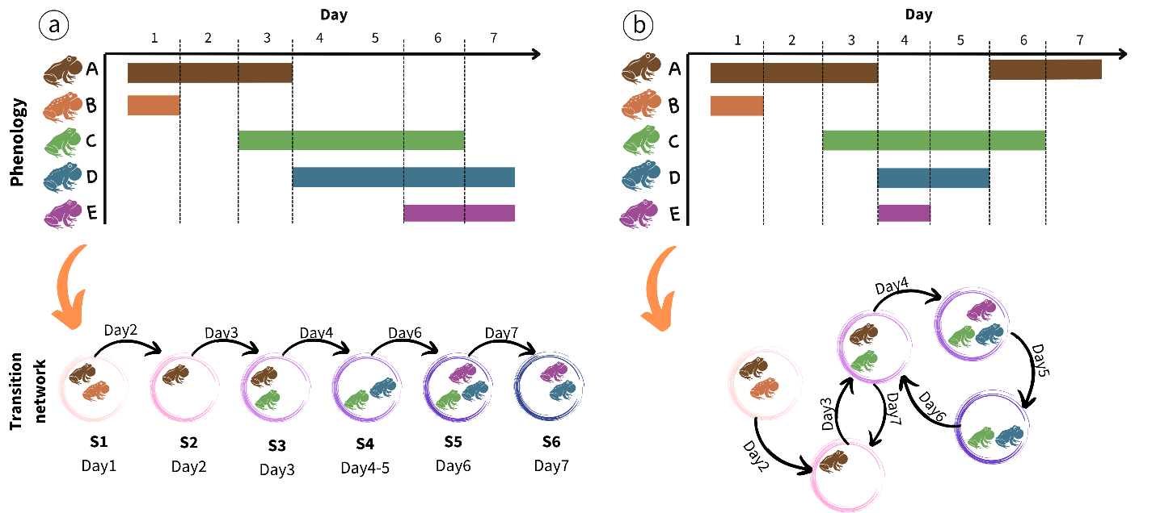Fig 1: Quantifying intra-annual changes in community structure with transition networks. Transition networks are created based on the phenology data of community members (colored horizontal bars). Nodes represent community states, defined by a unique combination of co-occurring species and links indicate transitions between states when species enter or leave the community (dashed vertical lines). Each node and edge has time stamps, creating a time-ordered network that fully captures the exact sequence and duration of and between changes in community structure on a fine temporal scale. We then test how the network architecture changes across years and sites, and climatic conditions by comparing key network metrics (Table 1). The left side shows a hypothetical example of a simple linear, sequential transition typically expected in classical seasonal succession; the right shows a more complex temporal structure with recurring states and repeated transitions found in this study.
The temporal architecture of communities
Quantifying key metrics (Table 2) that describe the architecture of the 192 transition networks revealed a highly dynamic seasonal community structure. In a single annual activity cycle, communities went through an average of 20.3 (±0.73 SE) unique community states (combinations of co-occurring species) and 88 (±1.99 SE) transitions between states, with up to 51 unique community states and 158 transitions (Fig. 2). This striking diversity of community states and high frequency of transitions within a single cycle was possible because each state lasted, on average, only 3.1 days (±0.05 SE). Notably, state durations followed a negative exponential probability density function $(P\left(d\right)\sim e^{-λd})$(Fig. S3), suggesting that the end of a state is independent of its duration and thus driven by external forcing rather than internal aging of nodes. This aligns with the fact that transitions between community states depend on the activities of all community members rather than the phenology of just a single species.
The transitions between states were moderately bursty (mean = 0.21 ±0.01SE, Fig. 2). We did not detect a signal of temporal memory (mean = -0.04 ±0.001, Fig. 2), indicating low predictability of the timing and duration of events. Together, these results reveal volatile and stochastic seasonal structure, with temporally clustered transitions between ephemeral community states, separated by longer “stable” periods with few changes in community composition. This temporal structure of events is consistent with the system's biology: Although breeding activity varies across amphibian species, it is still typically coordinated around the same stochastic rain events for most species (24), which helps explain the observed level of temporal clustering and stochasticity at the community level.
The sequence of community state transitions created complex, interconnected networks, with some clear general characteristics. Networks were typically modular (mean = 0.32 ± 1.03 SE, Fig. 2), revealing that states grouped into more interconnected seasonal clusters. This is consistent with the concept of “seasonal guilds” (25, 26), in which subsets of species overlap in their seasonal niches but differ in their fine-scale activity patterns. While connectance was on average low (mean: 0.15 ±0.006SE, Fig. 2) relative to the high node diversity, it is still surprisingly similar to the average connectance reported for most ecological networks(27). The short average distance between nodes (mean=2.18 ±0.07SE, Fig. 2) and a high betweenness (0.49 ±0.001SE, Fig. 2) indicate that the temporal transition networks of these communities exhibit a “small-world” structure, characterized by high path dependency and transitions between nodes that pass through a select subset of central or “hub” nodes. A closer inspection of individual networks revealed that these hubs were either “empty” states (no active species present) or states with a single species with a disproportionately long breeding season, like the bronze frog (L. clamitans). This important functional role of these hub species only becomes visible through a temporally explicit lens. Overall, this interconnected, small-world temporal structure contrasts sharply with the linear transition sequence that would arise from the simple seasonal succession commonly assumed for most systems (Fig. 1).
Stability and variation in seasonal structure
Determining whether climate-driven changes in the temporal organization of communities follow universal rules or are dictated by local contingencies is crucial for predicting the effects of climate change across heterogeneous landscapes. We found that the seasonal architecture of communities exhibited significant spatiotemporal divergence across sites and years (Fig. 2, Table S1, S2). For instance, the diversity of unique nodes (representing distinct community states) varied tenfold (5-51) across the 192 networks, and up to fivefold within individual ponds across years (Fig. 2). This variation was largely driven by changes in the cumulative annual species richness, which scaled log-linearly with node diversity (Fig. S1). Crucially, this scaling relationship was conserved across all sites, revealing a predictable, non-random assembly rule that links species richness to the diversity of realized community states. While exponential scaling between richness and connectance is well documented for traditional ecological networks (15), our results demonstrate that this relationship extends to time-ordered networks, potentially representing a universal rule for ecological communities across time and space. Furthermore, as the number of active species increased, the disparity between the observed and theoretically possible node diversity widened significantly (Fig. S1). This divergence highlights that the possible number of realized species combinations is strongly constrained by temporal overlap and should be common in any system with temporal niche partitioning. Since co-occurrence strongly determines species interactions (3, 28), our results indicate that the temporal structure of communities plays a critical, yet traditionally overlooked, role in shaping interaction networks.
After controlling for annual species richness, most temporal structure metrics still differed significantly across sites and years (Table S.2). The notable exceptions are betweenness, burstiness, and the significant positive correlation between the average duration of community states and their frequency of occurrence each year (r² mean = 0.561, range = 0.522-0.601, Fig. S2), which all remained relatively consistent across ponds. Despite their spatial consistency, these metrics still fluctuated substantially over time (Fig. 2, Table S.2). Consequently, while certain properties of community transitions appear conserved, the broader temporal architecture of communities is plastic, shaped by spatiotemporal variation in local environmental conditions and community composition.
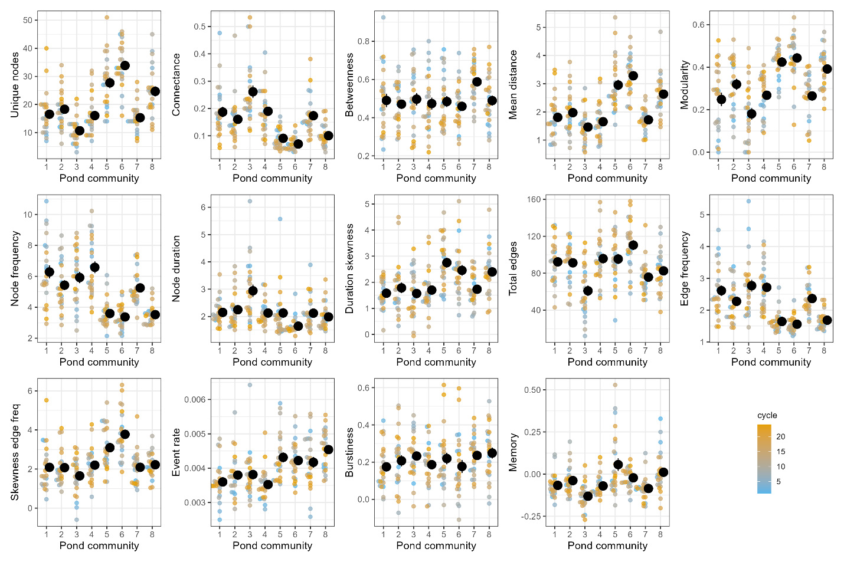
Figure 2: Temporal (seasonal) structure of community transitions varies across sites (ponds) and years. Solid black points indicate pond means ±1SE across annual cycles, and small points indicate the respective metric for a given year, with the color indicating the respective annual cycle. See Table 1 for details on network metrics.
Climate drives inter-annual variation in seasonal community structure
Climatic variability over the 24-year period accounted for a significant part of the inter-annual changes in the temporal architecture of communities. Specifically, 12 of the 14 transition network metrics were significantly associated with at least one principal component of weather variation (Table S1). This spanned all metrics of network topology, as well as the most node-level, edge-level, and temporal spacing properties (Fig. 3). While the effect of climate change on species phenologies is well-documented at the species level (9, 12), our results reveal the pervasive impact of climate forcing on the fine-scale temporal architecture of entire communities.
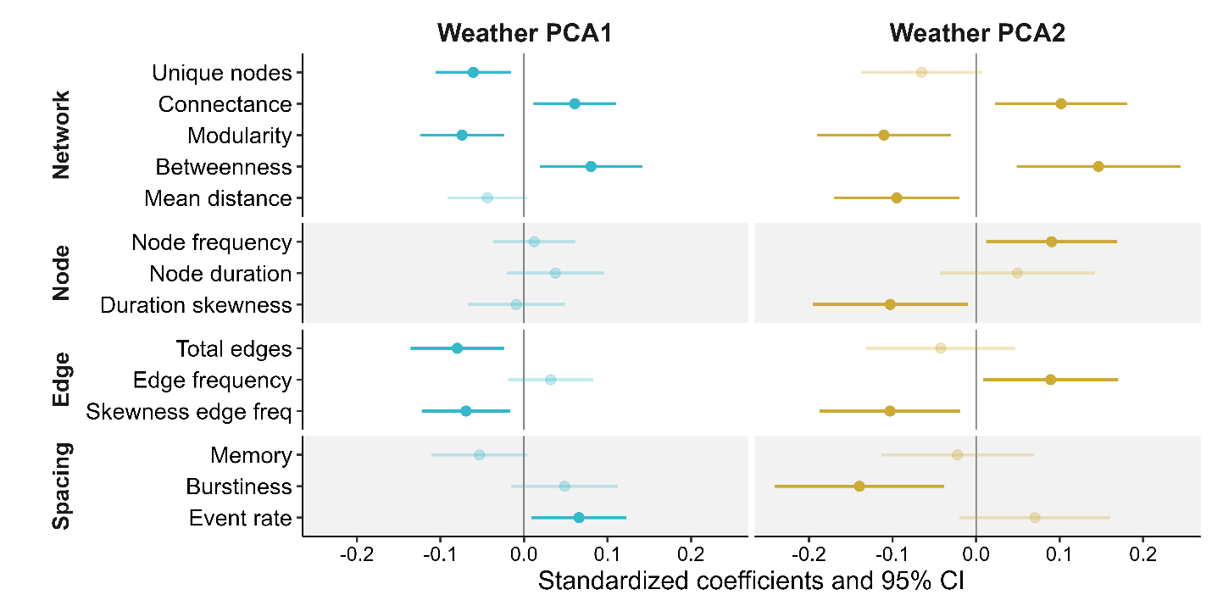
Figure 3: Changes in weather conditions help explain inter-annual variation in seasonal community transition networks. The X-axis shows the effect size of annual weather patterns on individual metrics that describe the key temporal organization of community states. For ease of comparison, all metrics and climate variables were standardized prior to analysis. See Table 1 for detailed explanation of metrics and Fig. S2 for details on PCA loadings.
Extreme climate events simplify the temporal architecture of communities
The multifaceted interplay among weather variables complicates isolating the role of individual drivers, but we can clarify these dependencies by focusing on extreme climatic events. Since both temperature and precipitation are the most important climatic drivers of amphibian breeding (24, 29), we focused on years with extremely high temperatures and drought conditions (see methods). We found the temporal architecture of communities changed significantly during years with extreme climate events, with drought conditions playing a larger role than extreme heat (Fig. 3). Unusually hot years triggered a shift toward more bursty (temporally clustered) transitions between community states and resulted in a more “extreme” long node durations (higher skew), but did not significantly alter other network metrics (Fig. 3). Extreme climate events are inherently rare, and even with a 24-year-long time series, we had only a handful of events, which likely limited the statistical power to detect subtle effects, especially given the natural variation in network structure across sites.
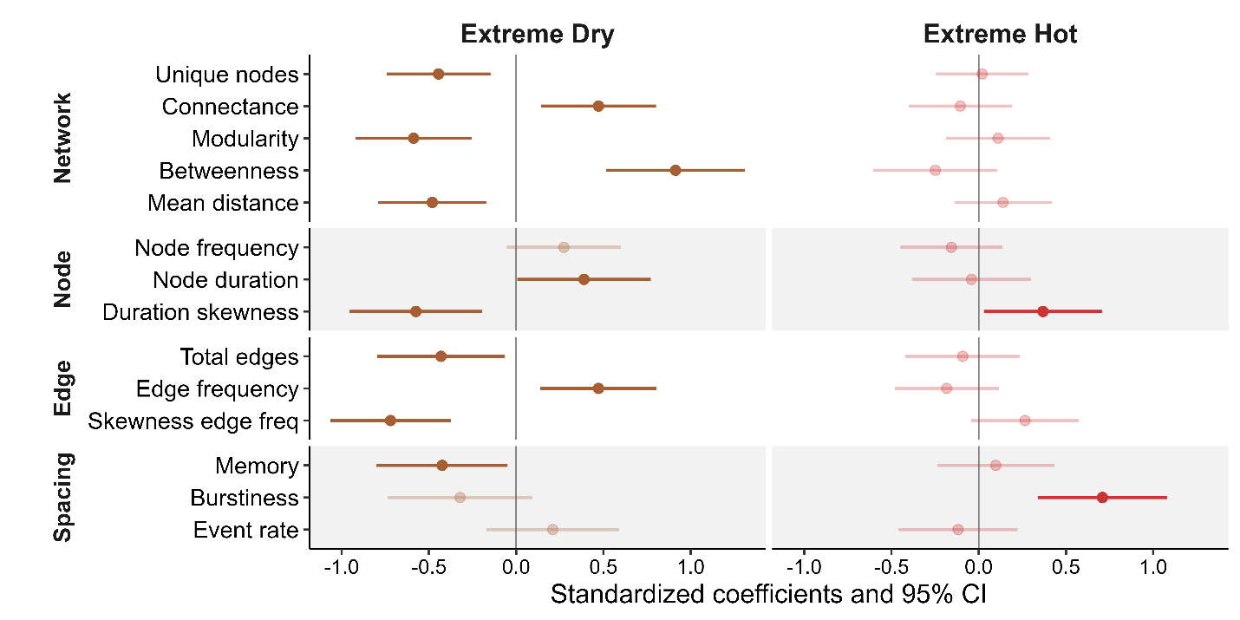Figure 4: Temporal structure of community transition networks changes in years with extreme climatic events. Changes in network metrics reflect temporal shifts in seasonal community structure under extreme dry (low cumulative rainfall and long dry periods) or hot conditions (high daily maximum temperatures and total number of hot days). See Table X for a detailed description of network metrics and Fig. 5 for extreme years.
In contrast, extreme drought restructured multiple aspects of the transition network, affecting 6 of 14 network metrics (Fig. 4). Under average climate conditions, communities had a ~25% higher diversity of community states. The drought-mediated reduction in network size was mostly driven by a loss of multi-species (three or more) states. However, this loss was independent of annual species diversity, which remained stable across extreme hot (P=0.235, χ² =1.41) and dry years (P=0.620, χ² =0.25). Instead, incorporating annual species richness as a covariate only strengthened the results (for all six metrics, Table SX), indicating that this network simplification was driven by changes in assembly rules rather than by taxonomic loss.
This drought-mediated reduction in network size was coupled with a significant increase in connectance, betweenness centrality, and frequency, while modularity and mean path length decreased (Fig. 4, Table SX). These shifts represent a fundamental reorganization of the network architecture: while normal years favored more sequential transitions between states, forming a “circular” topology, drought years converged on a simpler “star” shaped topology (Fig. 1). In this more centralized configuration, single-species and no-species states formed “hubs”, overriding the diverse modular transition patterns typical during normal conditions. This structural simplification suggests a breakdown in temporal coordination among species, in which extreme climatic forcing appears to override biological assembly rules, creating a more bottlenecked architecture that may reduce community resilience to additional perturbations.
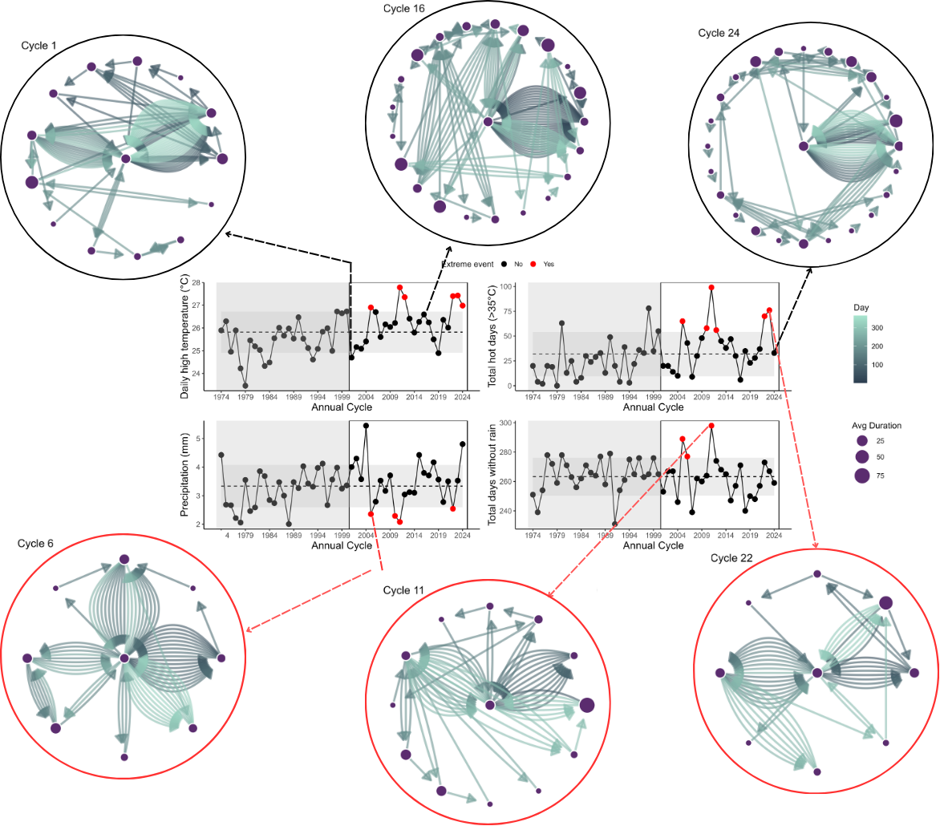Figure 5: The architecture of community transition networks differs between normal and extreme climate years. Nodes indicate unique combinations of co-occurring species (see Fig. 1), and their size indicates their average duration. Arrows indicate transitions between community states, with each color corresponding to a day. Top row shows example networks for normal years, bottom row shows extreme climate years for the same pond. The center graphs show annual averages for temperature and rainfall metrics used to identify extreme climatic events during the study period (red points). The dashed line and gray center band indicating the 50-year average ±1SE, respectively.
These patterns are consistent with the system’s biology. Amphibian breeding activity is strongly tied to precipitation (24), but because species have distinct seasonal reproductive windows (30), prolonged drought periods inevitably increase the temporal separation of species. This also weakens seasonal guild structure (as indicated by reduced modularity) and limits opportunities for co-occurrences and thus multi-species states (as reflected in lower node diversity). The notable exceptions are precipitation-insensitive species with prolonged breeding, like L. clamitans in our system, which emerge as central network hubs. Such differences in climate sensitivities are common across animal and plant taxa (8, 12), suggesting that these results should extend beyond amphibian breeding systems. Together, our findings highlight the role climate plays in shaping the temporal organization of communities and underscore the necessity of temporally explicit approaches to identify functional roles in systems driven by ephemeral resources.
Natural communities are complex, and any given metric and approach can only describe part of this complexity. Here, we focused on co-occurrence data, which are widely used to study environmental effects on community dynamics and interaction patterns (31-33). Extending this analysis to include abundance and direct interaction data could further enhance our understanding of the complex temporal structure of communities. Unfortunately, this data is still unavailable in most systems at fine temporal scales, and current analytical approaches are not yet designed to incorporate this information into temporal networks. However, future advances in technology and computational methods are advancing quickly and hopefully will soon overcome this limitation (6). Furthermore, incorporating microclimate differences across sites could help explain some of the spatiotemporal differences across sites observed in our study.
Implications
Amphibians are among the most climate-sensitive (34) (35) and threatened taxa globally (23). Our results indicate that climatic extremes are not only threatening individual species but also the temporal architecture of entire communities. The co-occurrence of species determines what interactions are possible and their outcome (3, 6, 28) and the temporal patterns in adult breeding activity are correlated with the temporal community structure of the next generation (tadpole communities) (26). Thus, the observed shifts in the temporal architecture are expected to alter interactions at both the adult and larval stages of amphibians, with cascading effects for community dynamics and the crucial functional roles they play in both terrestrial and aquatic ecosystems.
The temporal architecture of communities is an emergent property of the phenological responses of all community members and their coordination. The small-world transition network architecture and the response to climate variation we discovered here are driven by species' phenological plasticity. Phenological plasticity is a common key adaptation to seasonal environments (36-42), suggesting that extreme climate events should alter the temporal structure of communities in most natural systems. However, climate sensitivities vary across taxa (8-12, 35, 40), and systematic differences in the temporal architecture of communities across systems and regions could modify the effect of extreme events. Given the highly dynamic and ephemeral nature of amphibian breeding activity, our results likely represent some of the most sensitive and dynamic communities along this natural spectrum, and we expect that systems with slower species turnover and less plastic phenologies may exhibit different and potentially less sensitive temporal structures. As fine-resolution long-term phenology data become more available for entire communities, identifying how differences in temporal architecture shape communities' responses to climatic variation is a critical next step toward fully understanding the ecological and evolutionary factors that shape natural ecosystems and their sensitivity to environmental change. Here, we’ve taken a first step by outlining a methodological framework for tackling this challenge and revealing the rich insights we can gain from a temporally explicit approach to community ecology.

Methods
Quantifying temporal community structure with transition networks
We used time-ordered transition networks to capture the temporal structure of communities within a year (6). This approach treats each unique combination of species as a node, and links between nodes indicate a change in community structure when species enter or leave a community. Each node and link has one or more associated timestamps, which indicate the time intervals during which a specific community state or link was active. The structure of such a time-ordered transition network thus depends on the exact sequence and timing of changes in community structure over time. For instance, if states only occur once, we obtain a simple linear network structure, whereas repeating nodes would result in a more complex interconnected network structure (Fig. 1). Importantly, any difference in how a given community changes over time is mirrored in a concurrent change in the structure of these time-ordered transition networks, which we can capture by comparing network metrics (6).
Study system & phenology data collection
Amphibians are an excellent system to study the link between the temporal structure of communities and climate. The timing and duration of breeding activity vary across species (43-46), resulting in intra-annual changes in calling communities. Because their breeding activity is closely tied to temperature and rainfall, their phenology is significantly influenced by year-to-year variations in weather conditions (24). Furthermore, because species use different climate cues, they also vary in their phenological responses (47), which can reshuffle the temporal structure of amphibian communities across years (30, 46). Finally, Amphibians exhibit some of the strongest phenological responses to climate change (48), and they are the most threatened vertebrates globally (23). Identifying how amphibian communities are affected by climate change and extreme events should therefore be a high priority.
We collected high-resolution data on the calling activities (reflecting their respective breeding phenologies) of 12 amphibian species at eight different sites (ponds) in South-East Texas for 24 years (2001-2024). Details of pond characteristics and data collection methods are provided in Carter et al. (2019). Briefly, ponds are clustered in two geographic areas: the Davy Crockett National Forrest and the Stephen F. Austin Experimental Station, with an average distance of 7 km and a maximum distance of 34 km between ponds. We recorded calls each night for six consecutive 1-minute periods during peak calling time (hourly from 21:00 to 3:00) using an automated audio recorder at each site. We processed recordings manually with sonogram references to identify 12 species (Acris crepitans, Gastrophryne caroliensis, Hyla versicolor, Hyla cineria, Incilius (Bufo) valliceps, Anaxyrus (Bufo) woodhousii, Lithobates catesbeiana Lithobates clamitans, Lithobates sphenocephala, Lithobates palustris, Pseudacris crucifer, Pseudacris triseriata). These species interact locally, either via acoustic interference or competition for common resources in the adult or larval stage. To quantify annual changes in community structure, we converted the hourly calling data to nightly presence/absence data of each species and divided the data into annual breeding cycles (“frog years”), which we based on the activities of all species across all years and started on December 7th (see supplemental file).
Climate Data
Amphibian breeding activity in temperature regions is primarily driven by temperature and precipitation patterns (24, 29). We obtained daily weather data on both data types from the closest public local weather station situated between both pond clusters (Lufkin, Angelina Co. Airport, TX, 31.23593, -94.75468), including daily precipitation (mm), and daily maximum (Tmax) and minimum (Tmin) temperature. In addition, we obtained daily integrated drought severity metrics from the National Integrated Drought Information System (drought.gov), which considers a range of variables to indicate the amount of “missing” rain in an area. We converted the daily five categorical drought indices into a single metric by weighing each category relative to its severity and summing across all categories.
The daily weather was then binned into annual reproductive cycles (“frog years”) to calculate summary statistics for each cycle, including average highest and lowest daily temperature (meanTmax, meanTmin), the sum of extreme hot days (HotDays, i.e. daily Tmax > 35ºC), average daily precipitation (meanPrec), the burstiness of daily rainfall (BurstRain) to capture variation in the number of days between rainfall events, and cumulative number of days without rain (DaysNoRain). These annual weather metrics differed substantially across the 24-year period: The average daily temperature low (meanTmin) and high (meanTmax) per cycle ranged from 8.59 -15.23ºC and 19.30-27.78ºC respectively, with 6-99 days above a maximum temperature of 35ºC per year, and cumulative precipitation from 758.7-1990.1. Finally, we identified years with “extreme” climatic events as those falling outside ±1 SD of the mean over the past 50 years for each metric. We created two different sets of extreme years based on temperature versus precipitation: extreme hot years (years with 1 SD above the average mean Tmax or HotDays) and extreme dry years (years with 1 SD below the average meanPrec or above the average number of DaysNoRain). This approach ensured that we only picked the most extreme years during the study period, while providing enough statistical power to compare metrics across extreme vs normal years. Note that this includes the 5 hottest years recorded in the past 100 years, and 5 driest years recorded in the past 50 years. Thus, the years represent true climate extremes.
Table 1: Metrics to quantify different aspects of the temporal structure of communities.
Scope | Metric | Description
Network | Node diversity | Metric of network size indicating the total number of unique community states
 | Connectance (weighted) | Metric of network density indicating average transitions (in & out) per community state
 | Modularity | Metric of network structure; higher values indicate more grouping/clustering of community states
 | Betweenness centralization | Metric of network centrality; high values indicate network “bottlenecks” or key node hubs
 | Mean Distance (Average Path length) | Metric of network efficiency; lower values indicate signals can spread faster (small word structure)
Node | Frequency | Average frequency a community state appears
Node | Duration | Average duration of states
Node | Skewness of duration | Asymmetry in state duration
Edge | Weight | Average frequency of transitions between states
 | Skewness of weight | Asymmetry in frequency across different transitions
Temporal spacing | Burstiness | Temporal distribution of community transitions
Temporal spacing | Memory | Correlation of durations between transition events
Temporal spacing | Event rate | Rate at which transitions accumulate over time

Data analysis
We converted species phenologies to transition networks of communities for each pond and cycle, resulting in total of 192 individual community transition networks (24 years x 8 sites). We focused on different aspects of the temporal structure by calculating a range of key network metrics falling into four broad categories (Table 1). First, we used a time-ordered daily transition network to quantify the durations and frequencies of occurrences of each state, and how these two are correlated. We also calculated the burstiness, memory, and rate of state transitions to determine the temporal spacing patterns of events and the time interval between events. Burstiness determines whether transitions occur randomly, evenly spaced, or aggregated in time. Memory indicates how intervals between events are correlated. Event rate quantifies the average speed at which transitions cumulate over time. To further quantify the transitions patterns between community states, we converted the daily transition networks into an annual Markov transition network, where each link between nodes is directed and weighted by the frequency of its occurrence. For each network, we calculated several key metrics to quantify network structure (the number of unique nodes, connectance, modularity, mean distance, and betweenness weighted by edge frequency), nodes (average number of node occurrence, average and skewness of node duration), and edges (total number of edges; average and skewness of edge frequency). Together, these four groups of metrics (Table 1) provide a detailed picture of how the temporal structure of communities changes over a cycle at a given site and year.
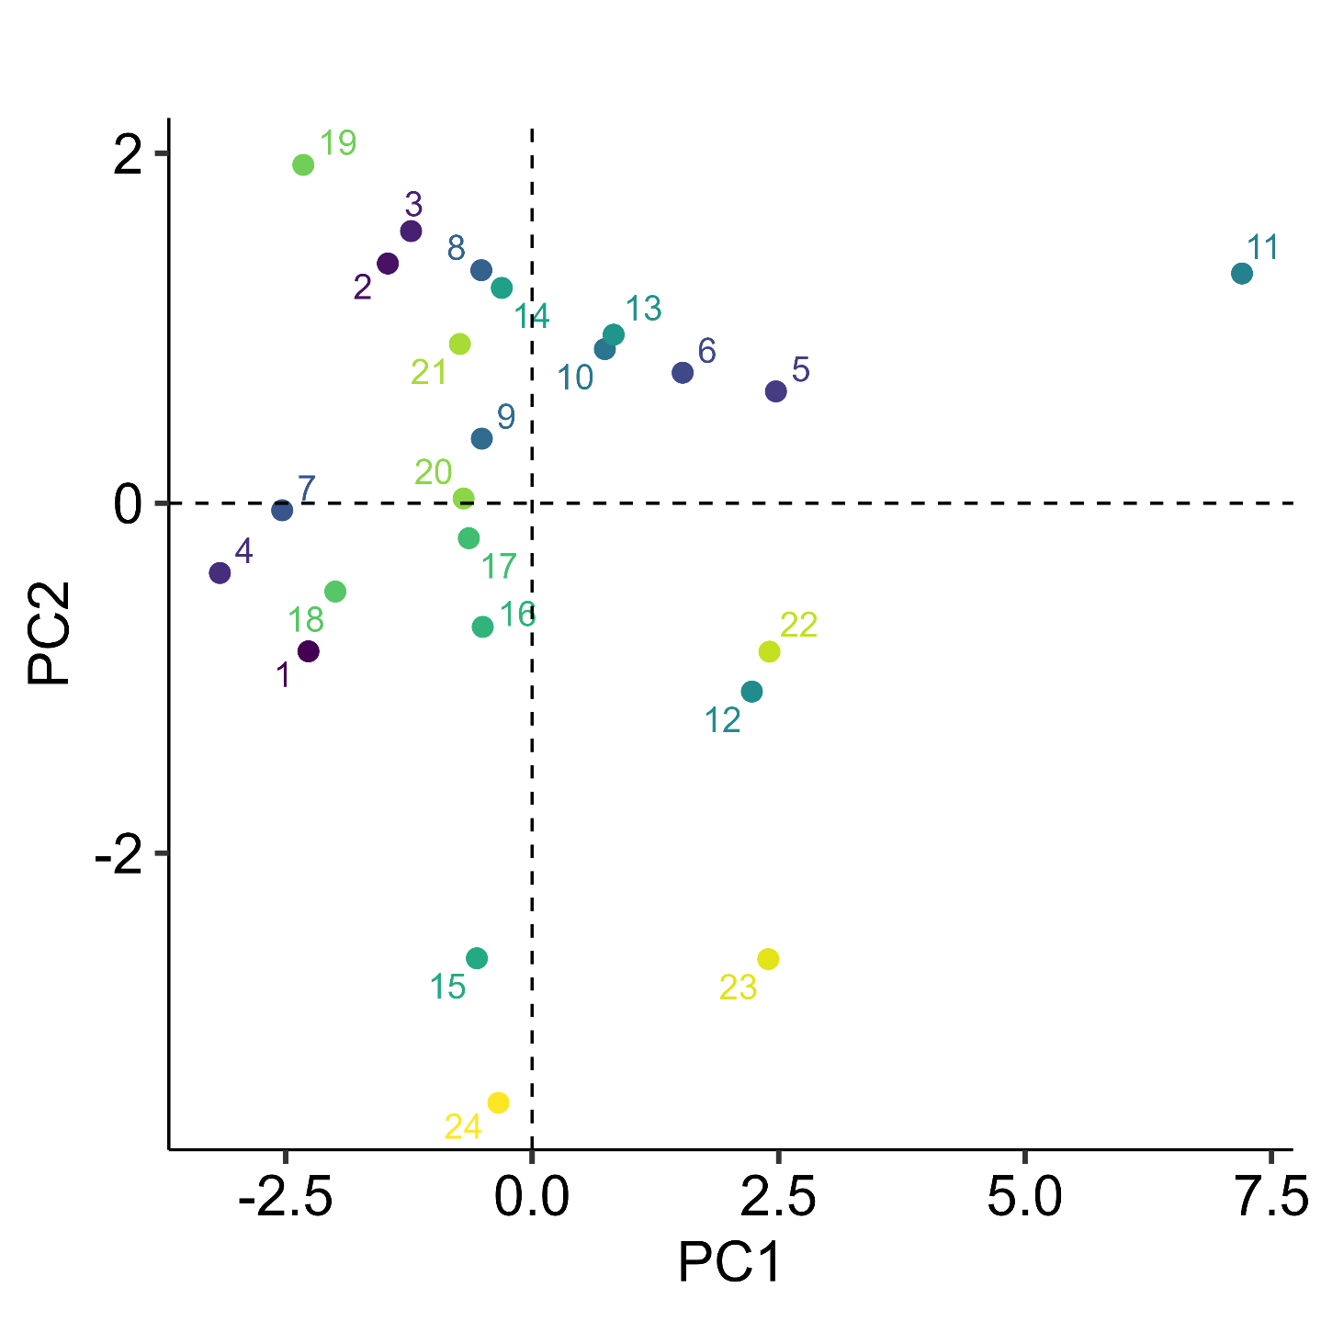
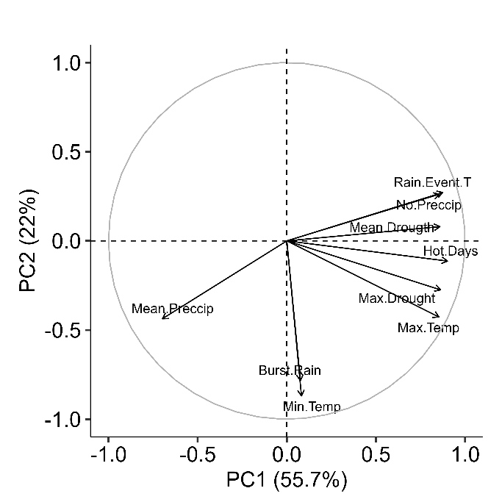
Figure x: Principal component analysis indicating annual differences in climatic variables. Points and color indicate values for a given annual cycle from 2001-2024. Insert shows loading of the nine different annual weather metrics.

When analyzing how variation in climate affected the community transition patterns, we first standardized all climate and network metrics using a z-score transformation (each variable has a mean of 0 and a standard deviation of 1). We then used a PCA analysis on these standardized metrics to mitigate issues of variance inflation caused by the inherent collinearity among climate metrics. The PCA analysis showed that 78% of the variation in the metrics could be captured by just the first two principal components (PC1= 54.3% & PC2 =23.8%) and any subsequent principal component added <7.6% (Supplement Fig on Axis, see Supplement Fig x for axis loading). We used general linear mixed models and the respective standardized network metrics as response variables, the first two weather principal components as predictors, and pond (site) as a random effect to account for non-independence of repeated observations across years. We also tested how network metrics differ across extreme climate years, using GLMs with extreme heat and drought years each as bimodal predictors, and pond as a random effect. All models fit best with normally distributed errors, except Connectance and mean Distance, which were both log-transformed to improve model fit and error distribution assumptions.
We tested how sensitive the results are to small gaps in calling activity by repeating the analysis in four ways: the original raw data, which treated all days without calling as absence, and three separate analyses that assumed species were still present when gaps (breaks) between calls were only either one (g1), two (g2), or three days (g3). So, if a species is called on days 1 and 3 but not on day 2, it would be considered absent in the raw data, whereas it would be considered present for all three days in the other scenarios. Overall, we found that ignoring small gaps did not qualitatively change any of the patterns and only weakened or strengthened some effects, indicating that our results are robust. Consequently, we present only the results based on raw calling data in the main text (see the supplement for additional analyses).
References
1. B. Schwarz et al., Temporal scale-dependence of plant–pollinator networks. Oikos 129, 1289–1302 (2020).
2. P. J. CaraDonna et al., Seeing through the static: the temporal dimension of plant–animal mutualistic interactions. Ecology Letters 24, 149–161 (2021).
3. J. M. Olesen, J. Bascompte, H. Elberling, P. Jordano, Temporal dynamics in a pollination network. Ecology 89, 1573–1582 (2008).
4. P. J. CaraDonna et al., Interaction rewiring and the rapid turnover of plant–pollinator networks. Ecology letters 20, 385–394 (2017).
5. T. Petanidou, A. S. Kallimanis, J. Tzanopoulos, S. P. Sgardelis, J. D. Pantis, Long‐term observation of a pollination network: fluctuation in species and interactions, relative invariance of network structure and implications for estimates of specialization. Ecology letters 11, 564–575 (2008).
6. H. Yin, V. H. W. Rudolf, Time is of the essence: A general framework for uncovering temporal structures of communities. Ecology Letters 27, e14481 (2024).
7. E. M. Wolkovich, B. I. Cook, K. K. McLauchlan, T. J. Davies, Temporal ecology in the Anthropocene. Ecology Letters 17, 1365–1379 (2014).
8. S. J. Thackeray et al., Phenological sensitivity to climate across taxa and trophic levels. Nature 535, 241–245 (2016).
9. O. Ovaskainen et al., Community-level phenological response to climate change. Proceedings of the National Academy of Sciences 110, 13434–13439 (2013).
10. F. Duchenne et al., Phenological shifts alter the seasonal structure of pollinator assemblages in Europe. Nature Ecology & Evolution 4, 115–121 (2020).
11. A. M. Iler et al., Maintenance of temporal synchrony between syrphid flies and floral resources despite differential phenological responses to climate. Global Change Biology 19, 2348–2359 (2013).
12. R. M. Prather et al., Current and lagged climate affects phenology across diverse taxonomic groups. Proceedings of the Royal Society B-Biological Sciences 290, 20222181 (2023).
13. D. W. Inouye, Climate change and phenology. WIREs Climate Change 13, e764 (2022).
14. H. M. Kharouba et al., Global shifts in the phenological synchrony of species interactions over recent decades. Proceedings of the National Academy of Sciences 115, 5211–5216 (2018).
15. F. Duchenne, R. O. Wüest, C. H. Graham, Seasonal structure of interactions enhances multidimensional stability of mutualistic networks. Proceedings of the Royal Society B-Biological Sciences 289, 20220064 (2022).
16. F. Duchenne, C. Fontaine, E. Teulière, E. Thébault, Phenological traits foster persistence of mutualistic networks by promoting facilitation. Ecology Letters 24, 2088–2099 (2021).
17. F. Encinas‐Viso, T. A. Revilla, R. S. Etienne, Phenology drives mutualistic network structure and diversity. Ecology Letters 15, 198–208 (2012).
18. J. D. Tonkin, M. T. Bogan, N. Bonada, B. Rios-Touma, D. A. Lytle, Seasonality and predictability shape temporal species diversity. Ecology 98, 1201–1216 (2017).
19. S. S. Suzuki, Y. G. Baba, H. Toju, Dynamics of species-rich predator–prey networks and seasonal alternations of core species. Nature Ecology & Evolution 7, 1432–1443 (2023).
20. K. O. Winemiller, Spatial and temporal variation in tropical fish trophic networks. Ecological Monographs 60, 331–367 (1990).
21. P. J. CaraDonna, N. M. Waser, Temporal flexibility in the structure of plant–pollinator interaction networks. Oikos 129, 1369–1380 (2020).
22. S. Kortsch et al., Disentangling temporal food web dynamics facilitates understanding of ecosystem functioning. Journal of Animal Ecology 90, 1205–1216 (2021).
23. M. C. Urban, Climate change extinctions. Science 386, 1123–1128 (2024).
24. D. Saenz, L. A. Fitzgerald, K. A. Baum, R. N. Conner, Abiotic correlates of anuran calling phenology: The importance of rain, temperature, and season. Herpetological Monographs, 64–82 (2006).
25. J. B. Wilson, Guilds, functional types and ecological groups. Oikos, 507–522 (1999).
26. C. M. Carroll, D. Saenz, V. H. W. Rudolf, Tracking phenological distributions and interaction potential across life stages. Oikos 2023, e09773 (2023).
27. J. A. Dunne, R. J. Williams, N. D. Martinez, Food-web structure and network theory: The role of connectance and size. Proceedings of the National Academy of Sciences of the United States of America 99, 12917–12922 (2002).
28. J. Resasco, N. P. Chacoff, D. P. Vázquez, Plant–pollinator interactions between generalists persist over time and space. Ecology 102, e03359 (2021).
29. W. E. Duellman, L. Trueb, Biology of amphibians. (JHU press, 1994).
30. S. K. Carter, D. Saenz, V. H. Rudolf, Shifts in phenological distributions reshape interaction potential in natural communities. Ecology Letters 21, 1143–1151 (2018).
31. M. A. Freilich, E. Wieters, B. R. Broitman, P. A. Marquet, S. A. Navarrete, Species co-occurrence networks: Can they reveal trophic and non-trophic interactions in ecological communities? Ecology 99, 690–699 (2018).
32. L. A. Burkle, J. C. Marlin, T. M. Knight, Plant-pollinator interactions over 120 years: loss of species, co-occurrence, and function. Science 339, 1611–1615 (2013).
33. N. Galiana, J.-F. Arnoldi, F. Mestre, A. Rozenfeld, M. B. Araújo, Power laws in species’ biotic interaction networks can be inferred from co-occurrence data. Nature Ecology & Evolution, (2023).
34. D. Loughnan et al., Phenology varies with phylogeny but not by trophic level with climate change. Nature Ecology & Evolution 8, 1889–1896 (2024).
35. T. L. Root et al., Fingerprints of global warming on wild animals and plants. Nature 421, 57–60 (2003).
36. J. R. K. Forrest, J. D. Thomson, An examination of synchrony between insect emergence and flowering in Rocky Mountain meadows. Ecological Monographs 81, 469–491 (2011).
37. J. A. Dunne, J. Harte, K. J. Taylor, Subalpine meadow flowering phenology responses to climate change: Integrating experimental and gradient methods. Ecological Monographs 73, 69–86 (2003).
38. A. M. Iler, D. W. Inouye, N. M. Schmidt, T. T. Høye, Detrending phenological time series improves climate–phenology analyses and reveals evidence of plasticity. Ecology 98, 647–655 (2017).
39. K. Donohue, Niche construction through phenological plasticity: life history dynamics and ecological consequences. New Phytologist 166, 83–92 (2005).
40. C. Parmesan, G. Yohe, A globally coherent fingerprint of climate change impacts across natural systems. Nature 421, 37–42 (2003).
41. V. Radchuk et al., Adaptive responses of animals to climate change are most likely insufficient. Nature communications. 10, 3109 (2019).
42. O. Vedder, S. Bouwhuis, B. C. Sheldon, Quantitative Assessment of the Importance of Phenotypic Plasticity in Adaptation to Climate Change in Wild Bird Populations. PLOS Biology 11, e1001605 (2013).
43. K. L. Oseen, R. J. Wassersug, Environmental factors influencing calling in sympatric anurans. Oecologia 133, 616–625 (2002).
44. S. K. Carter, V. H. W. Rudolf, Shifts in phenological mean and synchrony interact to shape competitive outcomes. Ecology 100, e02826 (2019).
45. M. M. Thompson, J. J. Rowley, A. G. Poore, C. T. Callaghan, Citizen science reveals meteorological determinants of frog calling at a continental scale. Diversity and Distributions 28, 2375–2387 (2022).
46. M. F. Benard, K. R. Greenwald, Environmental Drivers of Amphibian Breeding Phenology across Multiple Sites. Diversity 15, 253 (2023).
47. J. M. Cohen, M. J. Lajeunesse, J. R. Rohr, A global synthesis of animal phenological responses to climate change. Nature Climate Change 8, 224–228 (2018).
48. C. Parmesan, Influences of species, latitudes and methodologies on estimates of phenological response to global warming. Global Change Biology 13, 1860–1872 (2007).

Acknowledgments: We thank Cory Adams, James Childress and Alexandria Bryant for contributing in the field and lab. Additional thanks to Amy Dunham and …. for comments on the manuscript.
Funding: VHWR was supported by NSF DEB-2445952.
Contributions: Conceptualization, formal data analysis, writing - original draft: VHWR
Data Collection and curation: DS
Writing-editing: VHWR & DS
Competing interests: Authors declare that they have no competing interests.
Data, code, and materials availability: All data, code, and materials are freely available at:

Supplementary Materials
Materials and Methods
Supplementary Text
Figs. S1 to S#
Tables S1 to S#
References (##–##)
Supplemental Figures (key subset, see supplement for full list)
Figure S1: The diversity of community states in a transition network scales positively with the number of active species each year. The purple line indicates the hypothetical maximum number of unique states, assuming no phenological differences. Points indicate data of a given pond and year combination, jittered horizontally for clarity, and the green line and shaded area indicate the corresponding best-fit model and CI, respectively. Note log-scale of the y-axis.
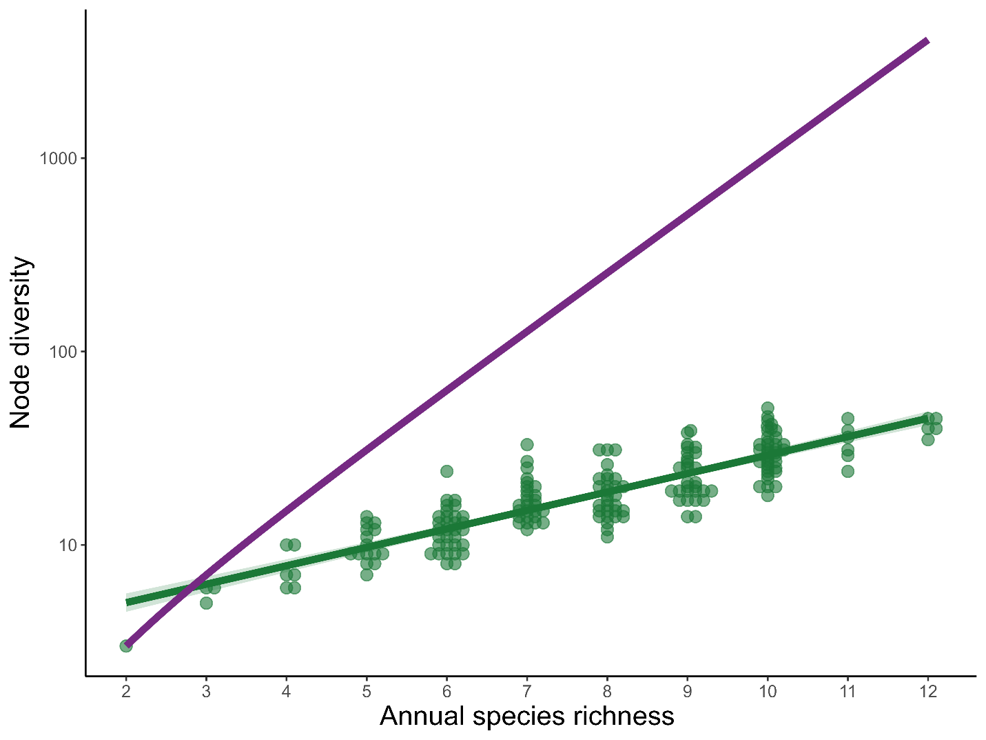

Figure S2: The duration and frequency of a state are positively correlated. Small points indicate the correlation coefficient (r²) between the frequency and duration of a community state averaged across a given year and pond, with the size of the point indicating the number of community states observed during a given year and color indicating the annual cycle. Large black points indicate mean ±1SE across years for a given pond community.
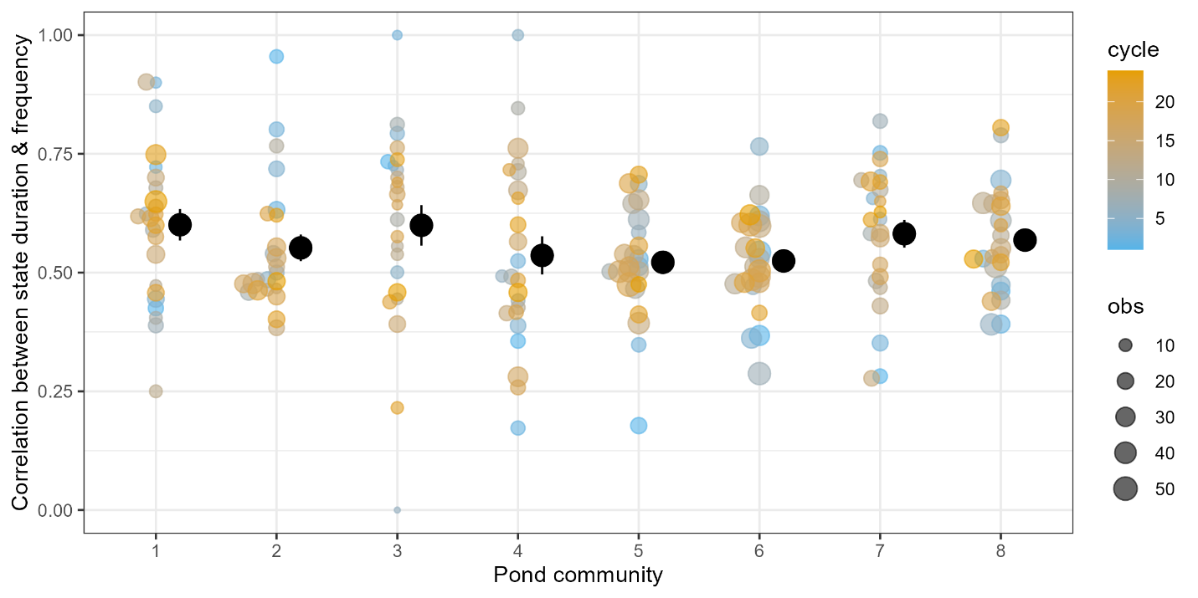

Figure S3: Frequency of node durations follow negative exponential probability density function. Black bars indicate density of node durations, with a fitted negative exponential function $P\left(d\right)\sim e^{-λd}$(green line). Each panel represents a given pond (1-8), including all 24 years. Note that a very small number of longer state durations were omitted for clarity. 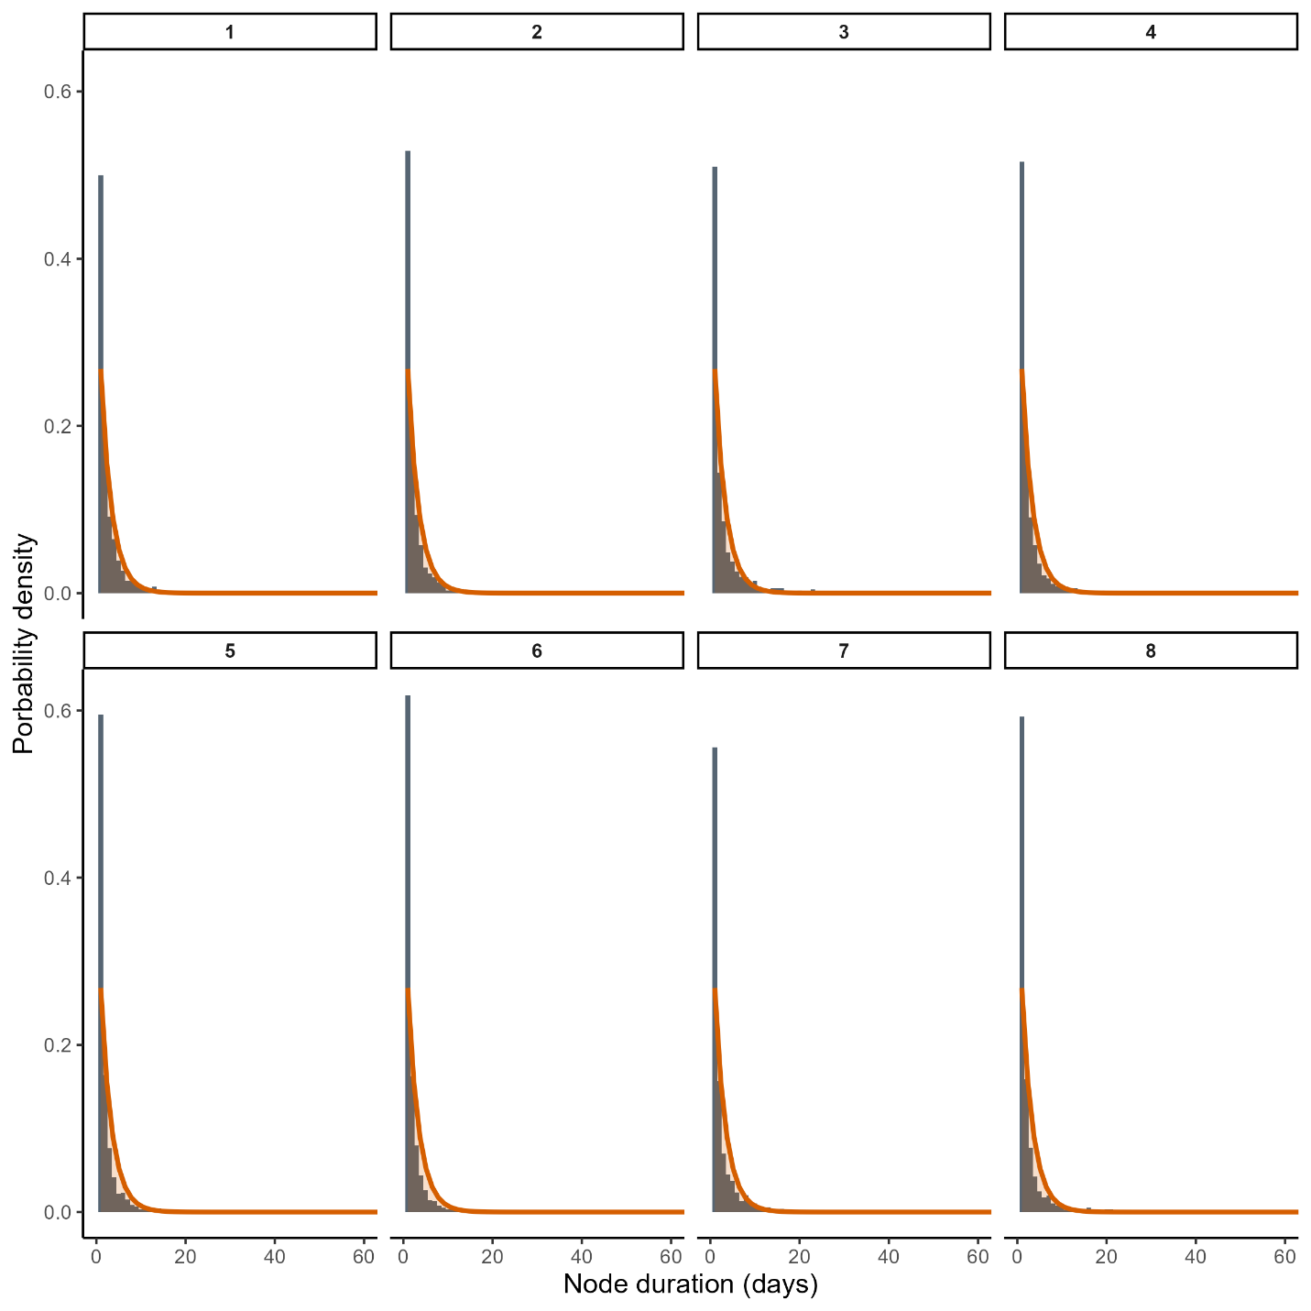

Table S1: Effect of pond identity and cycle on network metrics. Test statistic from a generalized additive model (GAM) fitted to each response variable to test the effect of pond, (annual) cycle, and their potential interactive effect (pond: cycle). The interactive effect was inferred from a lack-of-fit test and indicates whether adding a pond-specific smoothing term significantly improves the fit of the respective GAM. Cycle was fitted as a smoothing term to identify if there is a general temporal trend that is shared across all ponds.
response | pond |  | cycle |  | pond:cycle
response | F | p | F | p | F | p
Node diversity | 35.61 | 0.0000 | 2.84 | 0.0939 | 2.16 | 0.0000
Connectance | 19.12 | 0.0000 | 2.04 | 0.1552 | 0.28 | 0.0561
Betweenness | 2.24 | 0.0332 | 2.39 | 0.1236 | 0.92 | 0.0013
Modularity | 19.71 | 0.0000 | 2.84 | 0.1108 | 1.09 | 0.0001
Mean distance | 26.14 | 0.0000 | 2.38 | 0.1246 | 0.87 | 0.0085
Node duration | 8.00 | 0.0000 | 3.62 | 0.0586 | 0.69 | 0.0085
Node frequency | 24.03 | 0.0000 | 0.55 | 0.4600 | 1.18 | 0.0000
Duration skewness | 7.53 | 0.0000 | 1.39 | 0.2405 | 0.35 | 0.1138
Total edges | 11.07 | 0.0000 | 3.92 | 0.0493 | 1.28 | 0.0009
Edge frequency | 19.39 | 0.0000 | 2.43 | 0.1350 | 0.61 | 0.0068
Skewness edge freq | 13.73 | 0.0000 | 4.28 | 0.0400 | 0.68 | 0.0146
Burstiness | 1.24 | 0.2844 | 3.26 | 0.0729 | 1.16 | 0.0007
Event rate | 9.09 | 0.0000 | 3.01 | 0.0259 | 0.25 | 0.1368
Memory | 8.76 | 0.0000 | 0.63 | 0.4291 | 0.22 | 0.0966

Table S2: Effect of pond identity and cycle on network metrics after accounting for variation species number. Same as Table S1, but the analysis included the total number of active species observed at a pond each year as a covariate.
response | pond |  | cycle |  | pond:cycle
response | F | p | F | p | F | p
Node diversity | 9.72 | 0.0000 | 4.71 | 0.0313 | 1.06 | 0.0045
Connectance | 1.14 | 0.3373 | 3.60 | 0.0592 | 0.11 | 0.1766
Betweenness | 2.13 | 0.0430 | 2.34 | 0.1282 | 0.90 | 0.0013
Modularity | 3.41 | 0.0019 | 3.88 | 0.0504 | 0.52 | 0.0089
Mean distance | 6.53 | 0.0000 | 3.93 | 0.0489 | 0.22 | 0.1941
Node duration | 4.39 | 0.0002 | 1.38 | 0.2418 | 0.88 | 0.0036
Node frequency | 7.74 | 0.0000 | 0.61 | 0.4377 | 0.85 | 0.0005
Duration skewness | 2.54 | 0.0165 | 1.02 | 0.3138 | 0.45 | 0.0569
Total edges | 9.39 | 0.0000 | 2.50 | 0.1158 | 1.19 | 0.0003
Edge frequency | 2.83 | 0.0080 | 6.46 | 0.0119 | 0.35 | 0.0757
Skewness edge freq | 6.21 | 0.0000 | 2.70 | 0.1024 | 0.64 | 0.0214
Burstiness | 1.82 | 0.0859 | 3.97 | 0.0478 | 0.94 | 0.0032
Event rate | 6.00 | 0.0000 | 2.95 | 0.0270 | 0.23 | 0.1467
Memory | 4.26 | 0.0002 | 0.74 | 0.3921 | 0.22 | 0.1075

